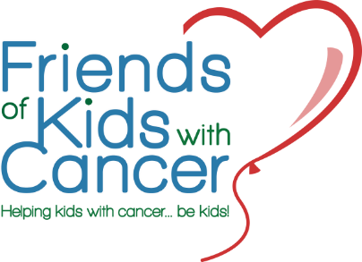
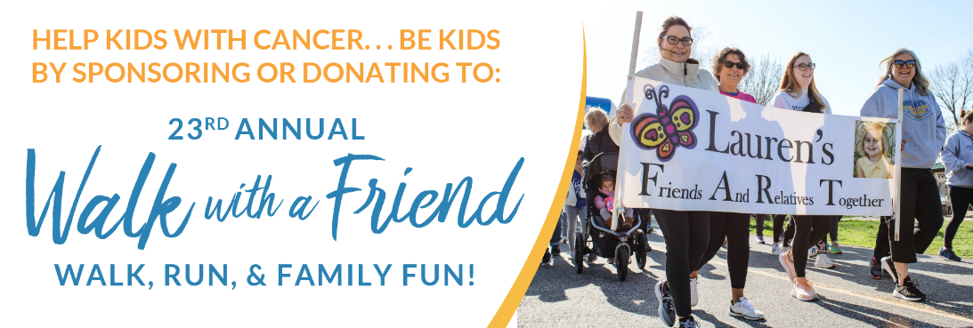

DATE & LOCATION
Saturday, April 15, 2022 (Rain or Shine)
Creve Coeur Memorial Lake Park
Sailboat Cove, 13725 Marine Avenue
Maryland Heights, MO 63043

REGISTRATION
7:30 a.m. – 8:30 a.m.
Day-of registration is required for participants who did not pre-register
or did not receive their t-shirt & running bib prior to the event.
T-shirt sizes can be exchanged AFTER registration closes.

PARKING
Park Rangers and volunteers will direct traffic in the Sailboat Cove parking lot.

WALK/RUN
Race begins promptly at 9:00 a.m. for runners.
Walkers will follow after a 5 minute delay.
The route will be open to the public during our event. Please share the path at all times.

EVENT INFORMATION
Free fruit, water, and coffee will be available.
Food trucks will be present for lunch, snacks, and beverages. Cash and credit cards will be accepted.
Teams will have reserved areas on the lawn. Large totes will be provided rather than tables this year for personal belongings.
Participants are encouraged to bring chairs, blankets, etc.

SHARE YOUR PHOTOS
Tag Friends in your social media posts!
Facebook: @friendsofkids
Instagram: @friends_of_kids

